

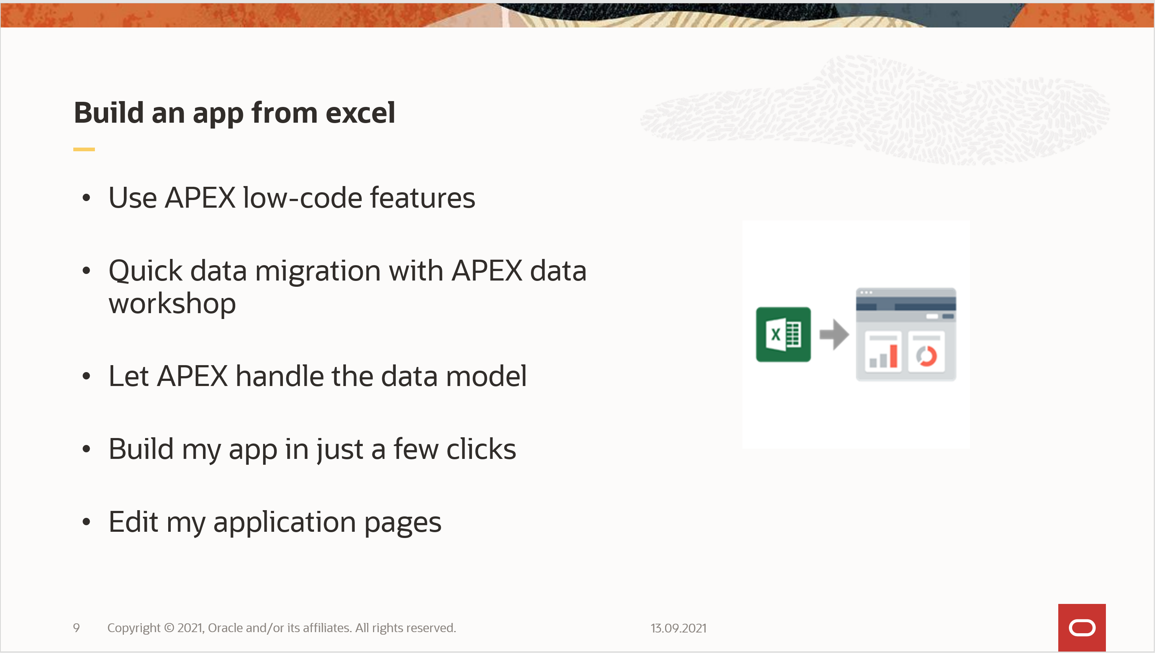

Author: Daniel Ivanescu  
Valid for APEX version 20.2

Steps:

1. Log into your Oracle APEX workspace

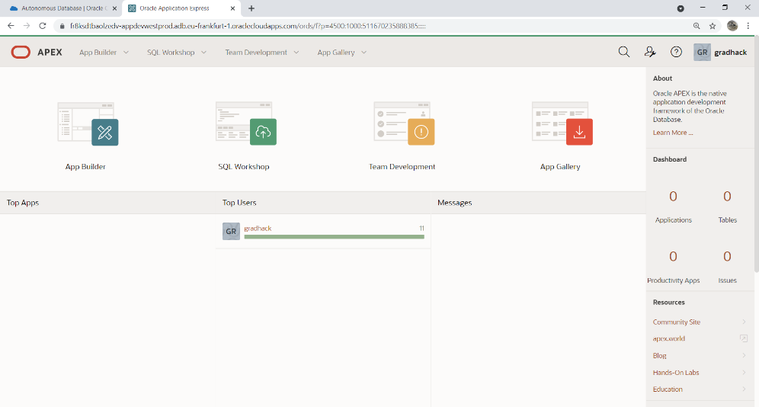

1. Navigate to SQL Workshop > Utilities > Data Worshop  
   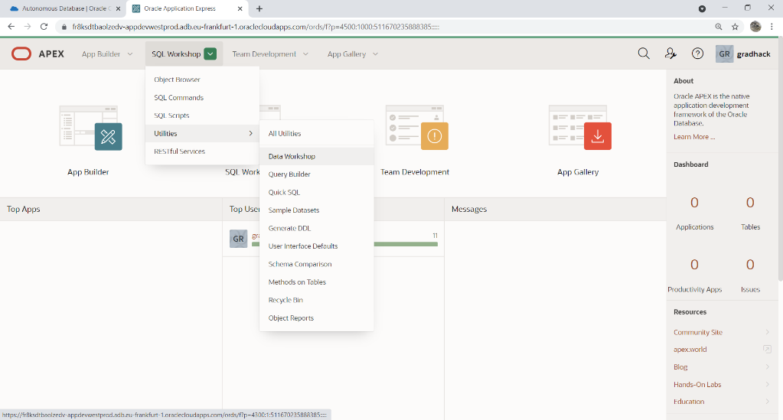
2. Click Load Data  
   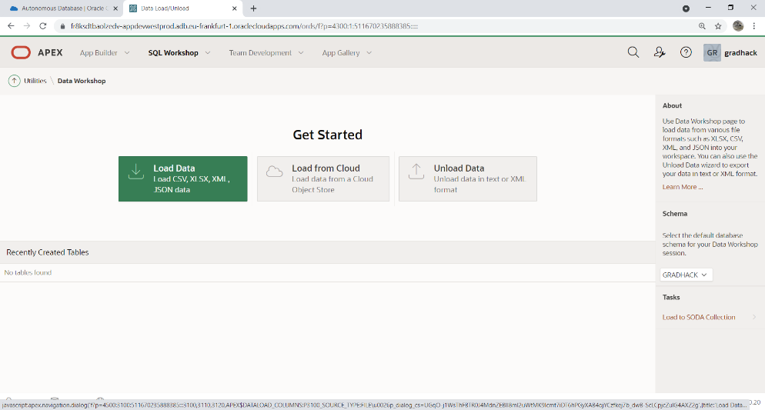
3. Drag and drop the “production_sites.csv” file in the Load Data region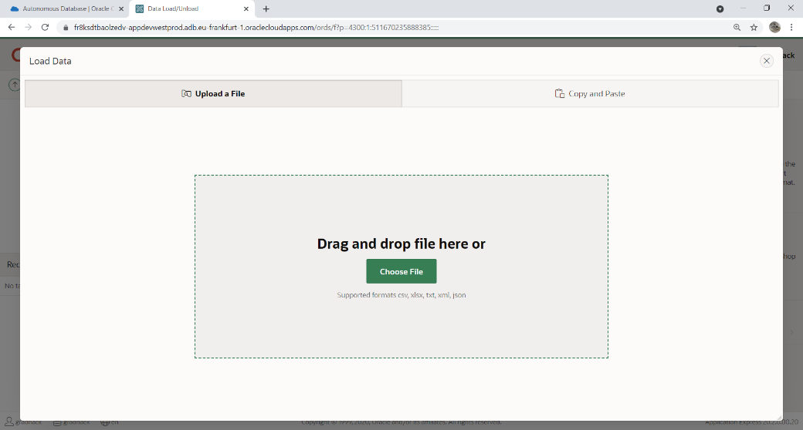
4. Choose Load To: New table  
   Type in table name “PRODUCTION_SITES”.   
   Click the button “Load Data”  
   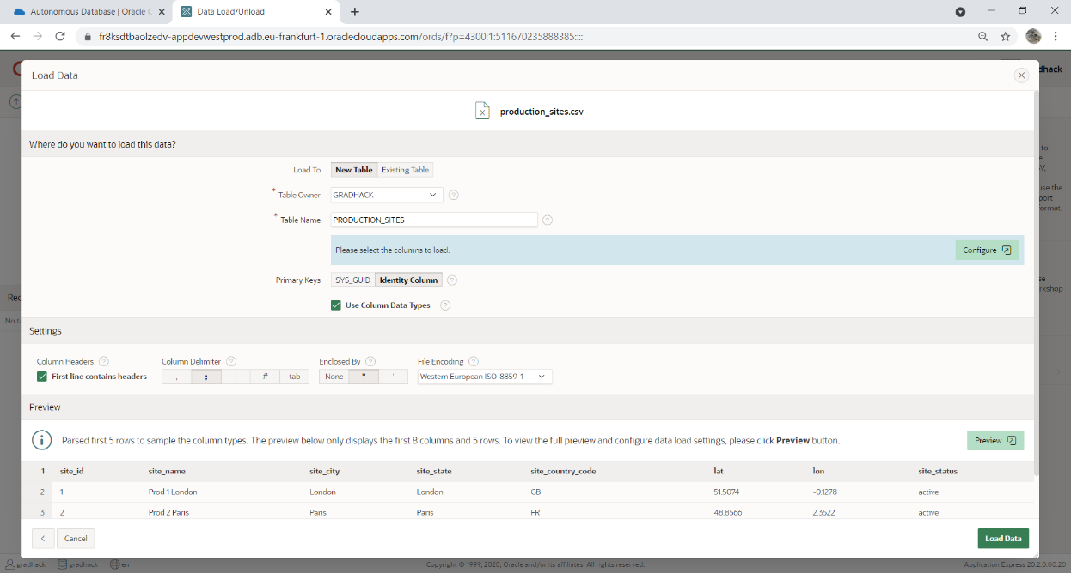
5. Click the button “Create Application”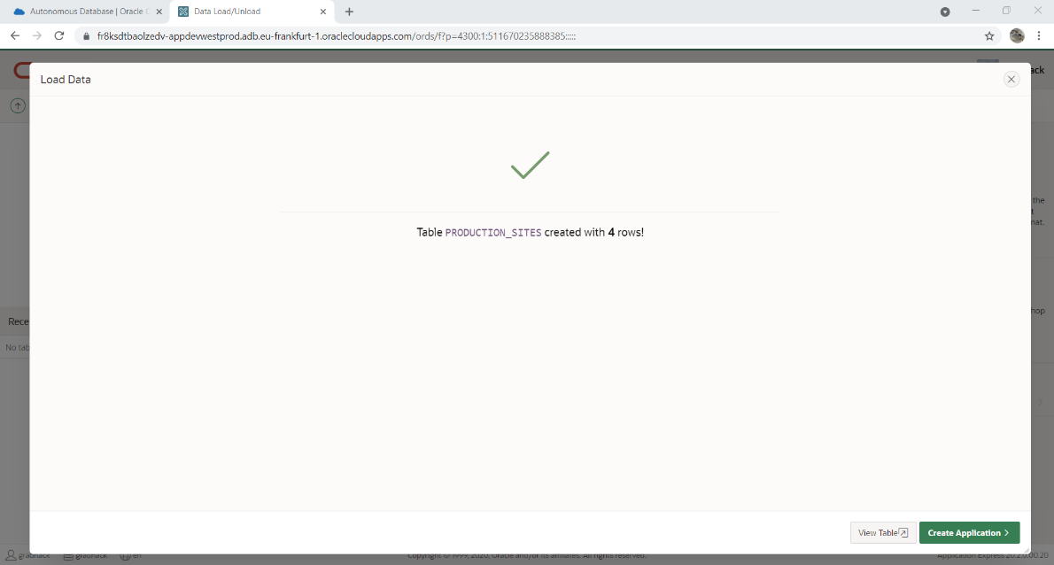
6. Enter Name “Production Sites”  
   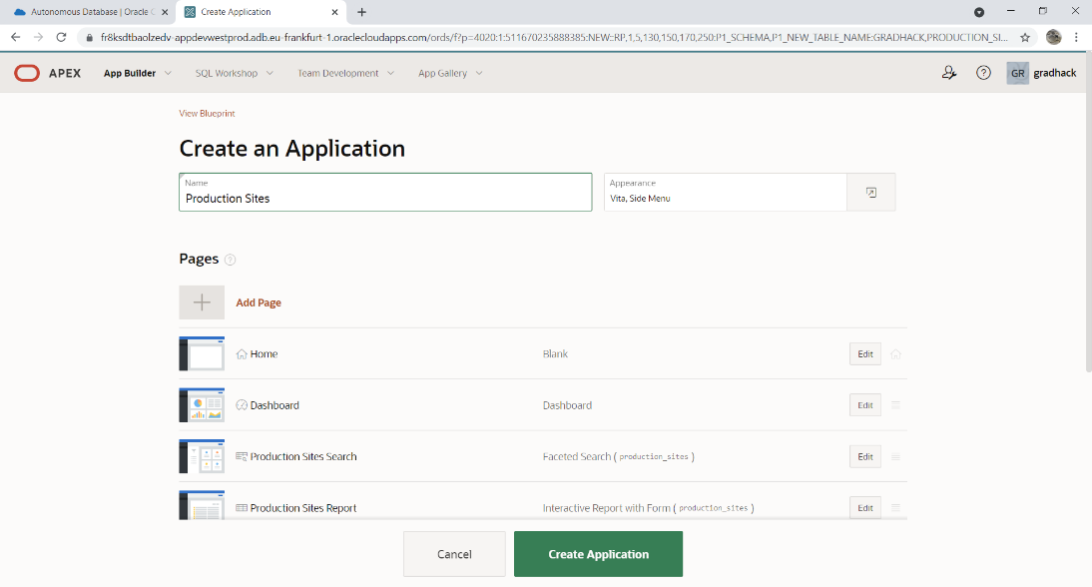
7. Click edit on “Dashboard” page row to edit / delete - optional  
   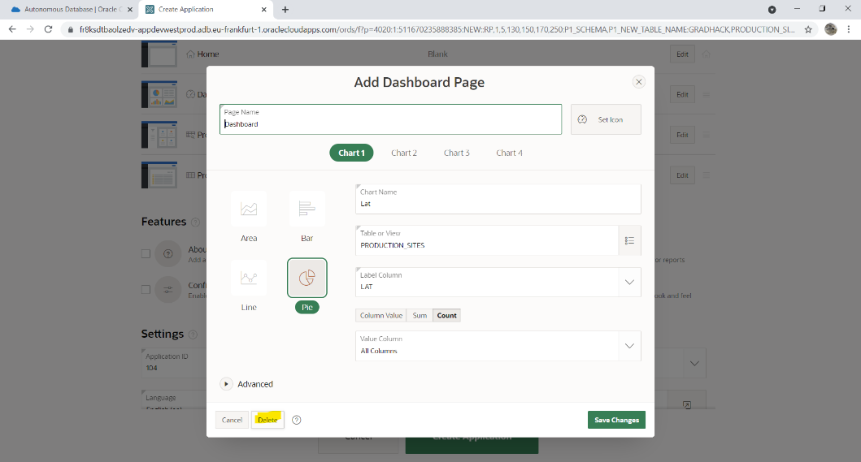
8. Click “Create application”  
   
9. Click “Run Application” or “Play” button to launch the application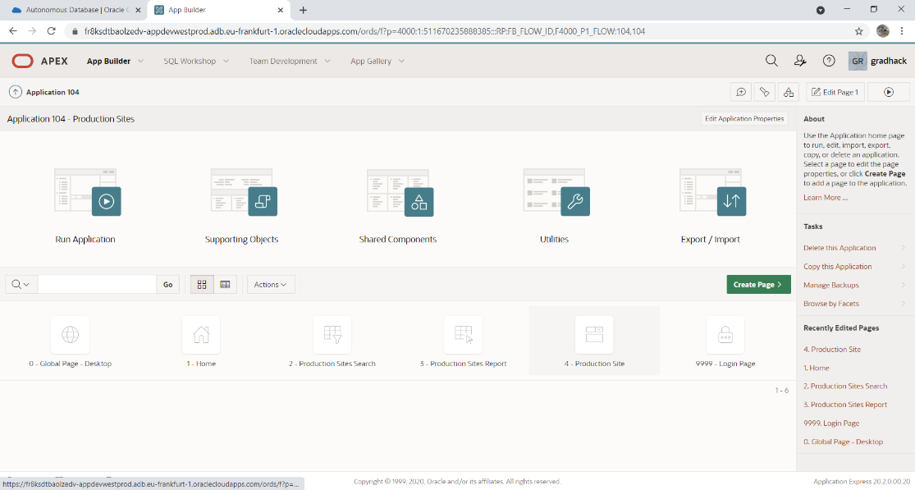
10. Log in with your APEX Workspace username and password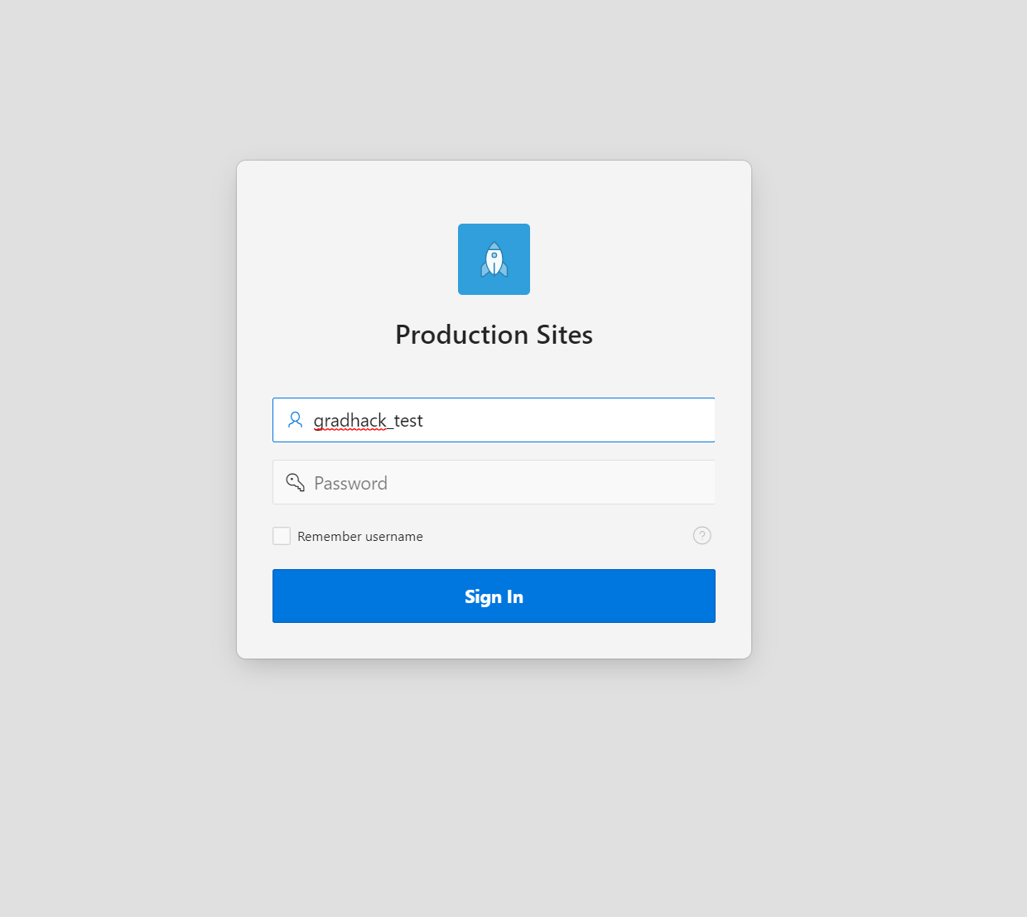
11. Welcome to your new application 